Mentoring Handbook Overview
Congratulations on being a part of Fairview’s Mentoring Program! Please use this handbook to help you make the most out of your mentoring relationship!

Table of Contents

The Role of the Mentee and Mentor 2
Actions for A Successful Mentoring Relationship 3
Mentee’s Development Goal: The Focus of the Mentoring Relationship 4
Goal Tracking Form 5
Mentoring Meeting Agendas 6
First Meeting Agenda 6
Agenda for Subsequent Meetings 7
Additional Questions 8

The Role of the Mentee and Mentor
At its core, mentoring is a relationship between two people who are working together to support the development of the mentee.
- The mentee is the person who is seeking insight and expertise to help them develop skills and advance a professional goal.
- The mentor is the person who is willing to share their ideas, perspective, and expertise to support their mentee’s achievement of a professional goal.

Overview of Roles
The Role of the Mentee | The Role of the Mentor
- Initiate communication and schedule meetings with the mentor | - Attend mentoring meetings with your mentee
- Identify a goal(s) you would like to accomplish | - Help mentee set agenda items
- Work with your mentor to set agenda for each meeting | - Share your expertise, thoughts, and ideas that support your mentee’s unique goal
- Build in time to reflect and consider how to apply new learnings | - Identify specific actions that will help your mentee achieve their goal
- Keep notes to share with your mentor about any progress (or lack of progress) you’re making towards your goal(s) | - Help mentee uncover new learnings
- Be an active listener | - Actively listen to determine where you can support and guide the growth of the mentee
- Be open-minded and ready to both receive and act on the feedback your mentor provides. | - Gently push your mentee outside of her/his comfort zone
- Use your mentor’s expertise, questions, and ideas to expand your own thinking | - Help mentee see opportunities s/he might not be aware of

Actions for a Successful Mentoring Relationship
 | Actions for the Mentee | Actions for the Mentor
Before | Schedule monthly meetings with your mentor. If a meeting is cancelled, reschedule the meeting as soon as possible. | Consider your own experience and strengths and what you will bring to the relationship.
 | Review the Mentoring Meeting Agendas and prepare for the meeting. | Consider how you might like to develop as a result of this relationship – it’s a two-way street!
 | Prepare to discuss your development goal and your progress toward the goal, including learning reflections. | Think about career highlights, relevant experience, and significant learnings that you can share with your mentee.
During | Keep an open mind to your mentor’s suggestions and ideas for how you can grow. | Ensure you have a clear idea of your mentee’s goals, so you can plan how to best assist and guide them in achieving them.
 | Reflect on how to apply new learnings and/or how application of new learnings went. | Share your expertise, thoughts, and ideas to support your mentee’s unique goal(s).
 | Create an action plan for steps you will take to reach your goals in between meetings. | Actively listen to your mentee. Remember that asking questions and staying curious is essential to understanding their goals and perspective.
After | Apply the actions you and your mentor discuss. | Share any relevant resources or connections with your mentee.
 | Spend time reflecting on how these actions went. | Start looking for opportunities to help your mentee grow!
 | Keep notes to share progress with your mentor or even lack of progress. Are there any barriers you need help removing to attain your goal(s)? | Be open to questions your mentee might have in between meetings.

Mentee’s Development Goal: The Focus of the Mentoring Relationship

Create the Goal
Prior to the first mentoring meeting, the Mentee will draft a development goal that will serve as the focus of the mentoring relationship. When drafting the development goal, the mentee should consider the following questions:

- What competencies did I select in my mentoring application and why?
- What area of my work could I improve in?
- What strength do I have that I could accelerate?
- What skills, knowledge, or behaviors will help me be successful at work?
- What do I want to be different at the end of this relationship?

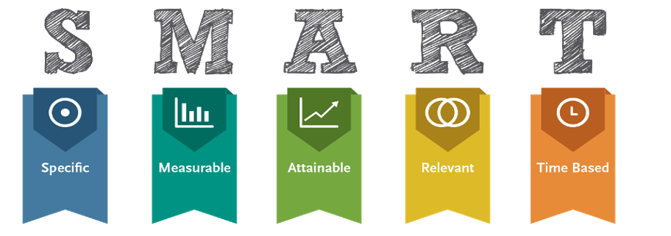
Make Sure the Goal is SMART
SMART stands for Specific, Measurable, Attainable, Relevant, and Time Bound. Using the SMART method to develop goals ensures purpose, clarity, and the ability to track progress toward it.

Mentee’s Draft Goal
Create a draft development goal to be discussed and finalized during first mentoring meeting.
________________________________________________________________________________________________________________________________________________________________________________________________________________________________________________________________________________________________________________________________________________________________________________________________________

Goal Tracking Form
This form is a tool to help track ideas and progress toward the mentee’s development goal. Use this Goal Tracking Form at each mentoring meeting to focus the conversation and track progress toward the completion of the goal. Add as many additional rows as needed.
Mentee: |  | Mentor: |  |  |  | Date:
Development Goal: | Example: I will develop my ability to provide exceptional patient care.
Growth Area | Ideas to Consider |  | Actions |  | Reflections
Breakdown of specific knowledge/skill/behavior development needed to achieve the goal | Ideas, perspective, and opportunities to build knowledge/skill/behavior shared during their mentoring conversation |  | Actions mentee commits to taking to build knowledge/skill/behaviors in the specific growth area |  | Reflections and learnings mentee had based on the actions taken between meetings.
Example: I will communicate intentionally and with clarity when transferring the care of a patient between shifts. | - Provide the bottom-line-up-front to ensure important messages aren’t lost in the detail  - Take steps to ensure accuracy of information |  | I will use the teach-back method to ensure the accuracy of what I hear. |  | The teach-back method ensured the accuracy of the information but the formality of the approach felt awkward.

Mentoring Meeting Agendas
Having a set agenda helps both the mentor and mentee make the most out of their time together. While each meeting may vary, below is a general outline for items that could be included in the first and subsequent meetings to ensure they are productive and meaningful.

First Meeting Agenda
Intent | Agenda Item
Get to know each other! | - Spend some time getting to know each other by talking about non-work topics (examples: family, hobbies, vacations, etc.)  - Discuss your professional backgrounds (work history, goals, values). Some potential questions you could ask:  - Tell me about your professional history. What was your career path?  - Why did you decide to join Fairview and why have you stayed?  - How have you decided which professional goals to pursue?  - Discuss past experiences with mentoring. What was successful? What other learnings did you have?  - Mentor share why they you volunteered to be a mentor. What are you hoping to get out of the experience?
Develop an agreement for your relationship | - Communicate asks and requests that you have for each other (e.g., level of confidentiality, communication requests, etc.)  - Identify how you will communicate with each other between sessions  - Agree on approach providing and receiving feedback
Finalize mentee’s goals | - Mentee will bring a draft development goal to the first meeting. Discuss the goal. Mentor help to shape the final goal.  - Use the Goal Tracking Form to write mentee’s goals in SMART goal format  - Identify up to three Growth Areas - specific knowledge/skill/behavior growth needed for the mentee to achieve the goal  - Record these in the Growth Area rows
Clarify actions to take before next meeting | - Verify the next meeting date, time, and location.  - Clarify action items and time lines.  - Seek feedback on the session content and effectiveness.

Agenda for Subsequent Meetings
Intent | Agenda Item
Previous Meeting Recap | - Review any actions that were taken since the last meeting. Reference the Actions section of the Goal Tracking Form for a reminder of commitments made.
Learning Reflection | - Reflect and share new learnings that are a result of these actions. Record these in the Reflections section of the Goal Tracking Form.  - How were you successful?  - Where do opportunities exist?  - What learnings can you implement, ongoing?
Goal Progress | - Review the Mentee’s Development Goal and the Growth Areas identified.  - Have dialogue with the intent of generating ideas about what the mentee can do to advance a Growth Area.
Action Planning | - Commit to, and recap, the actions the mentee will commit to taking over the next month.  - Log these commitments in the Actions section of the Goal Tracking Form.  - Repeat the Goal Progress and Action Planning sections for additional Growth Areas, as time allows.
Continued Connection | - Time for open dialogue.  - See Additional Questions section for ideas on how to keep connecting with each other.
Plan Next Meeting  (if applicable) | - Recap actions both parties will take before the next meeting.  - Confirm next meeting time and location.

Additional Questions
Here are some questions mentors and mentees can ask each other to better understand each other’s professional experiences.
Questions for the Mentor to Ask the Mentee | Questions for the Mentee to Ask the Mentor
What have you done over the last year that is helping you achieve your goals? | What do you wish you had known before taking your first leadership role?
What are some challenges you have? How do you overcome those? | Which leadership skills were most difficult to develop?
What strengths have brought you professional success? | What is your philosophy regarding…
What unique skills can differentiate you from others? | How do you lead your team regarding…
What motivates you? How do you get yourself to accomplish something? | How do you measure success? How do you ensure you achieve it?
What lessons have you learned from others? | Who inspires you? How do you inspire others?
How do you deal with uncertainty at work? | What values guide your leadership?
What professional relationships are challenging for you? | How do you lead through change?
What are you grappling with most right now? | How did you learn to think strategically?
How do you feel I can help you? | How do you manage conflict?

