Purpose
This is a template of the Performance Review form for leaders who had an employee transfer into their department during the performance year in question. The employee’s previous leader should use this document template to complete the review and send it to the employee’s new leader. The new leader can incorporate this feedback into the employee’s Performance Review.
When entering this information in Talent Connect, you will need to select a Rating in the system for each category. You can then copy and paste Leader Comments into the spaces provided in Talent Connect.
To copy and paste into Talent Connect:
- Use your cursor to highlight the text you wish to copy from the template.
- Right click with your mouse and select Copy.
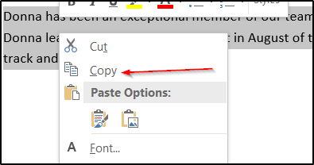
- Click in the appropriate Managers Comments box in Talent Connect.
- Right click with your mouse and select Paste.
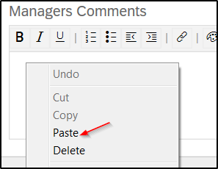
- Your comments have been pasted into the review form.
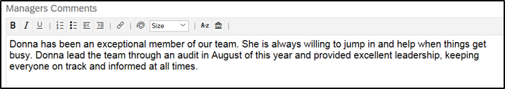

Performance Review Template
Employee Name: ___________________________________ Performance Year: ________

Performance to Goals
For the employee’s primary position, provide a rating for each goal the employee has.

Performance to Goals: Performance to Goals is the performance and accomplishments related to daily work/job duties, projects, initiatives, and goals aligned to Fairview’s strategic priorities and performance dimensions.

Rating (required – see ratings below):
- Exceptional
- Exceeds Expectations
- Meets Expectations
- Needs Improvement
- Unsatisfactory

Leader’s Comments (required):

Rating Definitions
Exceptional – Key contributor and role model to fulfilling organizational goals
Exceeds Expectations – Accomplishments frequently exceed expectations in achieving organizational goals
Meets Expectations – Achieves organizational goals as written
Needs Improvement – Organizational goals are not consistently achieved as written
Unsatisfactory – Organizational goals are not achieved
Commitments

Commitments: The Fairview Commitments guide behaviors that help achieve our organizational mission and vision. Respect for People and Continuous Improvement are the overarching Guiding Principles of our Commitments.

Please choose a rating for Respect for People and a rating for Continuous Improvement to represent how well the employee exhibits the Commitments that fall under each principle.
Add comments to describe how the employee specifically demonstrates each Guiding Principle. A rating is required.
Note: Most employees will fall into the “Meets Expectations” category.

Respect for People
Rating (required – see ratings and definitions below):
- Exceptional – A role model and inspiration; consistently surpasses demonstrating Fairview’s Commitments
- Exceeds Expectations – A role model; consistently exceeds expectations demonstrating Commitments
- Meets Expectations – Consistently demonstrates Fairview’s Commitments as written
- Needs Improvement – Inconsistently demonstrates Fairview’s Commitments
- Unsatisfactory – Consistently lacks demonstration of Fairview’s Commitments

Leader’s Comments (required):

Continuous Improvement
Rating (required – see ratings and definitions below):
- Exceptional – A role model and inspiration; consistently surpasses demonstrating Fairview’s Commitments
- Exceeds Expectations – A role model; consistently exceeds expectations demonstrating Commitments
- Meets Expectations – Consistently demonstrates Fairview’s Commitments as written
- Needs Improvement – Inconsistently demonstrates Fairview’s Commitments
- Unsatisfactory – Consistently lacks demonstration of Fairview’s Commitments

Leader’s Comments (required):

Individual Development Goal(s)
Individual Development Goal(s): These should describe areas the employee wants to focus on growing or becoming better at. Because development can take many forms, and on different timelines, Individual Development Goals are not rated.

Summary: In Talent Connect, leaders will see a calculated rating that reflects the employee’s Goals, Functional Excellence, and Commitments ratings and add comments.

Summary Comments:

